**Cybersecurity Policy Comparison: NZ Privacy Act 2020 vs GDPR**

|  |  |  |
| --- | --- | --- |
| **Feature** | **NZ Privacy Act 2020** | **GDPR (EU)** |
| **Breach Notification** | ASAP to Privacy Commissioner (no later than when affected individuals notified) | Within 72 hours to Supervisory Authority |
| **Right to Access** | Yes | Yes |
| **Right to Erasure** | No legal equivalent | Yes (“Right to be forgotten”) |
| **Data Localization** | Not required | Not required |
| **Fines** | Max NZD $10,000 | Up to €20 million or 4% of global turnover |
| **Cross-border Data Transfers** | Must take “reasonable safeguards” | Allowed only with adequate safeguards |

This project analyzes and compares key elements of the **New Zealand Privacy Act 2020** with the **European Union’s General Data Protection Regulation (GDPR)**. Both laws are designed to protect individuals' personal data, but differ in scope, enforcement, and data subject rights.

A notable difference is that **GDPR includes the right to erasure**, while New Zealand does not currently offer an equivalent. The **breach notification window** is more clearly defined under GDPR (72 hours), while New Zealand’s language focuses on notification “as soon as practicable.”

While GDPR can impose **multi-million euro fines**, New Zealand’s Privacy Act penalties are modest (max NZD $10,000). However, both emphasize transparency, accountability, and consent.

This comparison helps identify where local organizations may need to strengthen policies to remain globally compliant — especially if handling EU citizen data.

**1. Breach Reporting**

* **NZ**: "As soon as practicable" (no strict deadline)
* **GDPR**: 72 hours with detailed documentation

**2. Data Subject Rights**

* **NZ**: Right to access/correct only
* **GDPR**: Adds right to erasure ("be forgotten") and portability

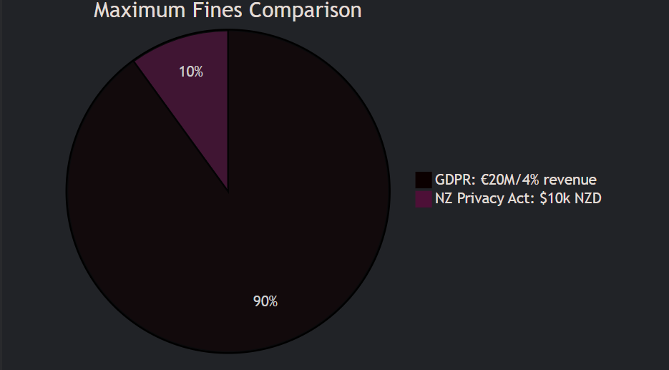

**Compliance Takeaways for Organizations**

* **For NZ Firms**: GDPR compliance automatically satisfies NZ Privacy Act
* **Critical Gap**: NZ lacks GDPR's "Privacy by Design" mandate (Article 25)

**Actionable Recommendations**

**For NZ Companies**:

* **Tag EU Data**: Implement metadata tagging for GDPR-protected records.
* **72-Hour Playbook**: Create a breach response template pre-approved by legal.
* **Privacy by Design**: Adopt GDPR’s Article 25 even if not legally required.

**For Auditors**:

* **Checklist**: Use this table to prioritize gap assessments.

**3. Compliance Roadmap for NZ Organizations**

**Step 1: Data Mapping**

* Tag all EU citizen data with GDPR_PROTECTED=True metadata

**Step 2: Process Alignment**

|  |  |  |
| --- | --- | --- |
| **Requirement** | **NZPA Solution** | **GDPR Upgrade Needed** |
| Breach Reporting | Internal playbook | 72-hour countdown procedure |
| Subject Access | Manual fulfillment | Automated erasure workflow |

**Step 3: Training**

* Conduct workshops on:
  + Recognizing EU vs. NZ data triggers
  + GDPR’s "Privacy by Design" principles

**4. Case Study: Auckland SaaS Firm**

**Challenge**: Nearly missed GDPR’s 72-hour breach window for EU users.  
**Solution**: Implemented:

* Automated alerts for breaches involving GDPR_PROTECTED tagged data
* Pre-drafted notification templates approved by EU legal counsel  
  **Outcome**: Avoided potential €50k fine.

**5. Resources**

* [Full NZ Privacy Act Text](https://www.privacy.org.nz/)
* [GDPR Official Guidelines](https://gdpr-info.eu/)
* [Compliance Checklist Template](https://your-github-link/)